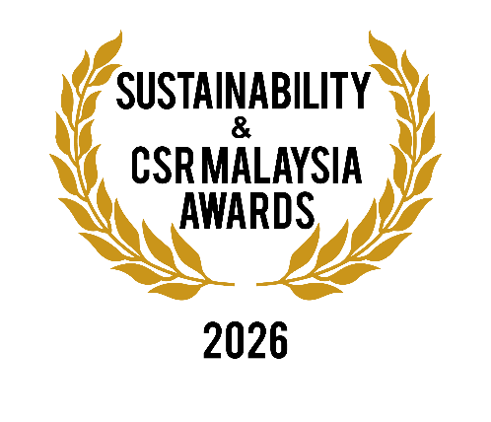
CORPORATE ENTRY FORM
(Incorporating ASIA SUSTAINABILITY PERSONALITY AWARDS 2026)

Category applied for ()

☐Corporate Category
☐Personality Category [ Asia Sustainability Personality Awards ]

☐Corporate & Personality Categories

Type of Company ()

☐Listed ☐GLC ☐ Foundation ☐Sdn Bhd ☐Others (please specify):

Name of Corporate Organization:
Personality Category (if applicable) – Name :
Position :
Address:

Tel: Fax:

Email: Website:
Name of CEO I MD I Chairman: Designation:
Head of Sustainability Division:

Contact No.: Email:

Nature of business:

Type of sustainability activities carried out in 2025 (continue on additional sheets if necessary):

Value of sustainability initiatives completed for 2025 (in RM):

Confirmation of the organization’s sustainability practices:

Please only tick where appropriate (do not tick if not applicable). This section must be completed by a senior management staff member who is authorized to make the following confirmation. A minimum of 8 ticks are required in order to proceed to the next level of selection by the Panel of Judges ( / )

☐Has a solid corporate sustainability policy aimed to create long-term stakeholder value through the implementation of a business strategy that focuses on the ethical, social, environmental, cultural, and economic dimensions of doing business

☐Well-being of employees, their families and members of the society are taken care of harmoniously in line with overall sustainability goals of the organization

☐It provides or aims to provide equal access to education and training for its employees at all levels

☐Does not practise gender biasness, in particular no discrimination, exploitation or violence against any individuals

☐Promotes clean and more efficient energy usage in its operations to contribute to a cleaner environment

☐Promotes sustained business growth, higher levels of productivity and technological innovation in connection with its business or activities

☐Does not participate in any form of forced labour, slavery and human trafficking whether directly or indirectly

☐Invests in infrastructure and innovation for the use of renewable energy in the business

☐Promotes responsible consumption of resources and production to reduce ecological footprints and to counterbalance the adverse effects of climate change

☐Helps prevent the loss of natural habitats and biodiversity, protects plant and animal life, and supports global food and water security and a more stable and peaceful world

☐Contributes to making cities and communities sustainable, safe and affordable, also for creating green public spaces, and improving urban planning and management (applicable for housing and infrastructure developers)

We hereby confirm that the above information is true and correct. We are aware that any information provided that are fraudulent will lead to disqualification. If the fraudulent information is discovered after the award presentation ceremony, the Organizers shall have the right to rescind the given award:

Signature: Company Stamp:

Name :
Designation :
Date :

Initial documents to be enclosed with the application/s:

1. Listing of all the CSR / sustainability / ESG activities and/or initiatives carried out in the year 2025
2. Photographs and/or videos of sustainability and CSR activities carried out in the year 2025
3. Sustainability report and statement (if available)

Notes:
- The Organizing & Selection Committee will contact the shortlisted applicant company for further information and photographs / write-ups of the company's CSR activities where necessary.
- A site visit or an online interview may be conducted where applicable
- The Organizer reserves the right to make changes to the date, time, and venue, and if necessary to hold the event on a smaller scale if it deems fit.

